**Asset Allocation (Portfolio Theory)**

1. Preferences under uncertainty

* Use *Return (Greed)* and *Risk (Fear)* to represent investment preferences under uncertainty
* Risk and return go hand in hand with each other
* We can think of each investment having two dimensions : risk and return.
* The objective is to pick the investments that have the best risk/return combination (trade-off).
* We measure “return” by using the *expected return: E( R)*
* we measure “risk” by using the *standard deviation of returns: σR*

[Mean-Variance Utility Function]

*Modeling* ***Preferences*** *using Utility Function “U”*

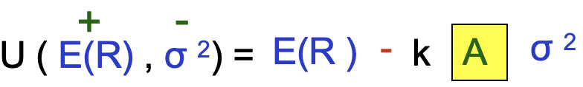

k = Scale factor = 0.5 (if decimals) 0.005 (if %)

A = Risk Aversion parameter The higher the A is, the more risk averse an investor is

i.e as RA increases 🡪 U decreases further as σ 2 goes up

<Example>

Suppose a risk-free asset has an expected return of 4%, and a mutual fund has an expected return of 10% and a standard deviation of 16%.

Which will you prefer if your degree of risk aversion is 4 using the utility function ?

U(risk-free asset)=0.04 (note: NO risk)

U(mutual fund)=0.1-0.5*4*0.16^2= 0.0488

[Type of Investors]

* **Risk Averse: A>0**

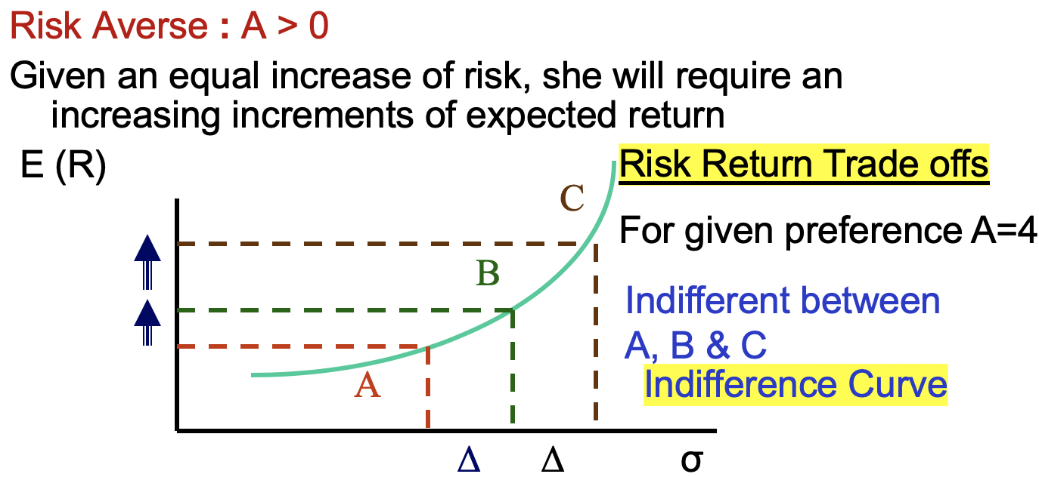

Need to diversify

Assume rational investors------risk averse

* **Risk Neutral: A=0**

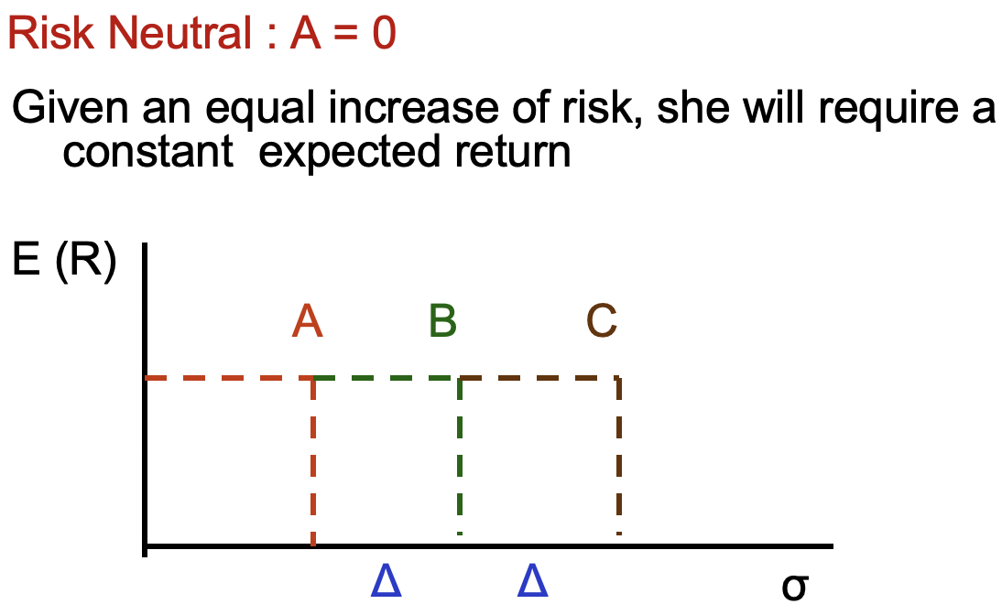

Not need to diversify

* **Risk Lover: A<0**

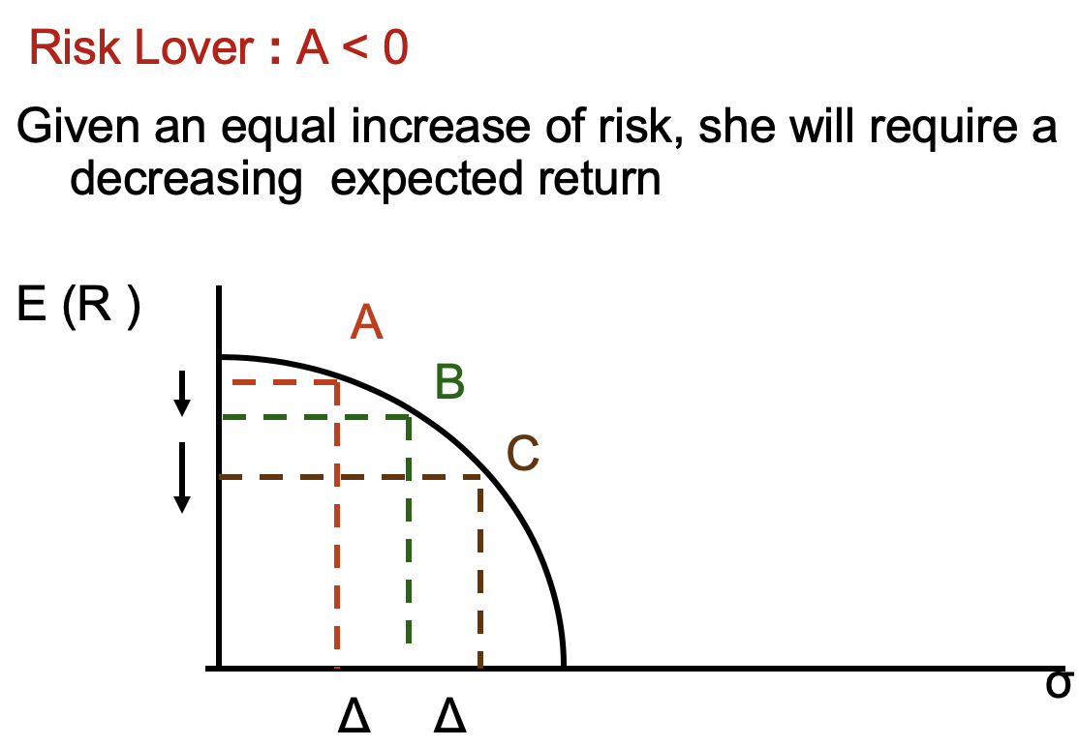

Not need to diversify

2. Returns

**Dollar returns vs. Percentage returns**

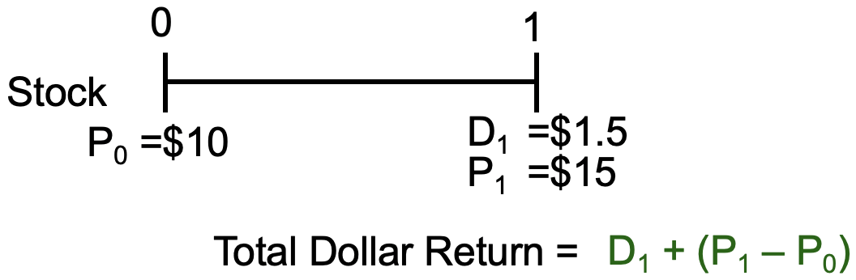

source of uncertainty

capital gain/loss

unchanged(determined by the policy)

Annual Holding Period Return-HPR= D1/P0 + (P1 – P0)/P0

dividend yield

capital gain/loss yield

1.5/10+(15-10)/10=65%

3. Predicting Return

* **Method 1 : Ex-ante Method:** Prospective

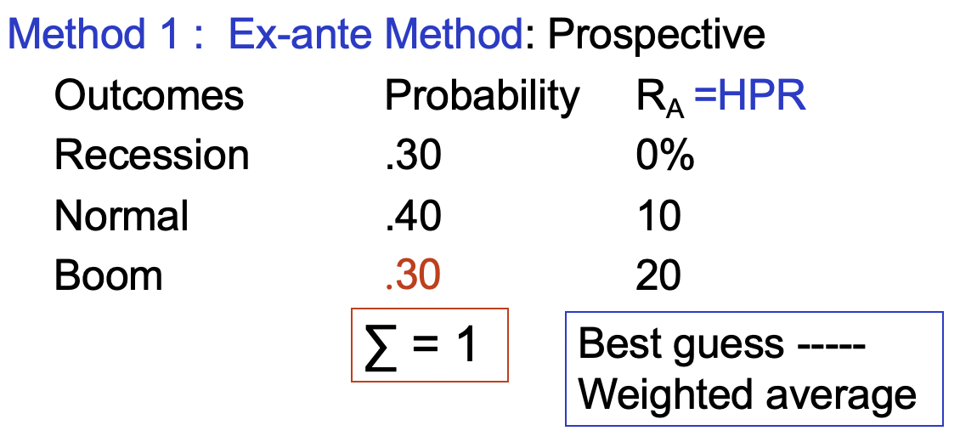

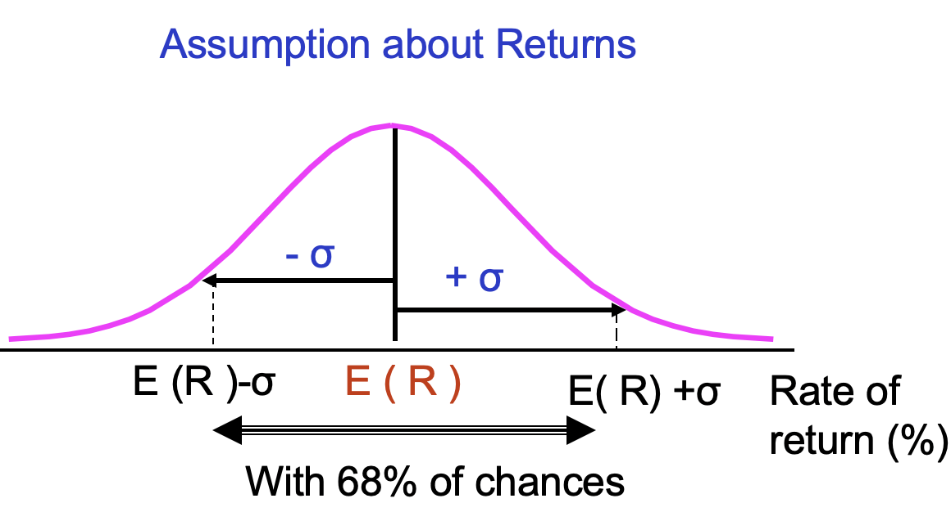

riskiness

Interpretation: 68% possibility return will fall in your prediction interval

E (RA)= Weighted average return

= Σ [ Rt * πt ]

= 0.3 * 0 + 0.4*0.1 + 0.3*0.3 = 0.1

Variance of A = Σ { π*[ Rt - E(R)] 2 }

= 0.00600625

Standard deviation is the square root of variance

σ = 0.0775

* **Method 2 : Ex-post Method**

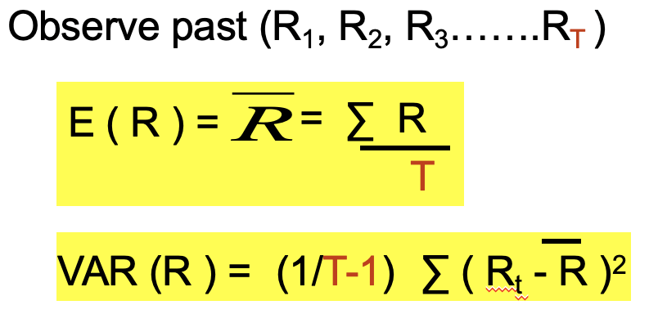

The larger the T (50 or 60 years 🡪 infinity), the better

<Example>

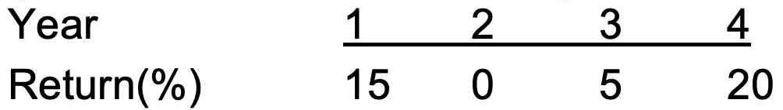

E(R)=(15+0+5+20)/4=10%

VAR=1/3(0.05^2+0.1^2+0.05^2+0.1^2)=0.83%

σ=0.0913=9.13%

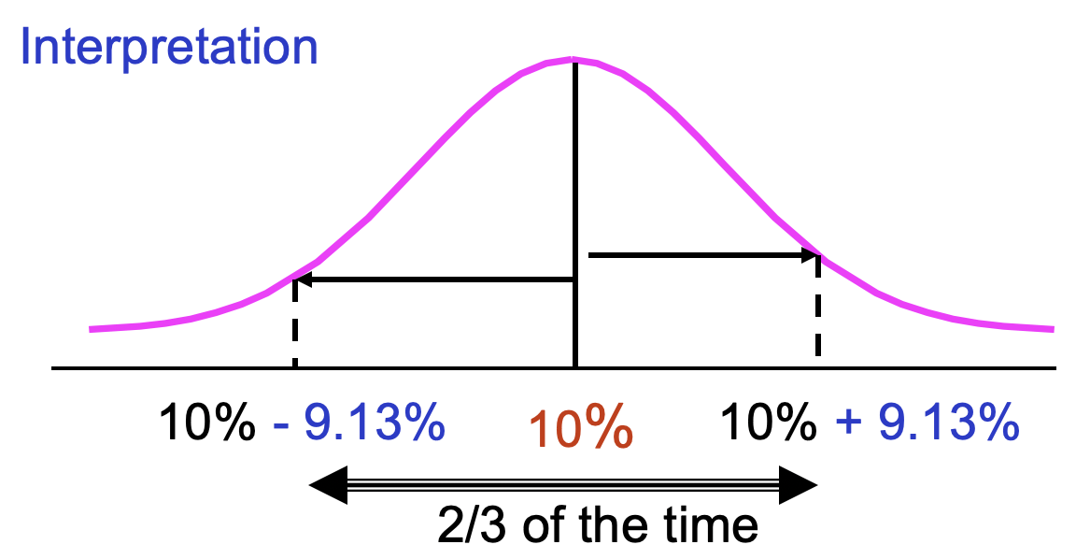

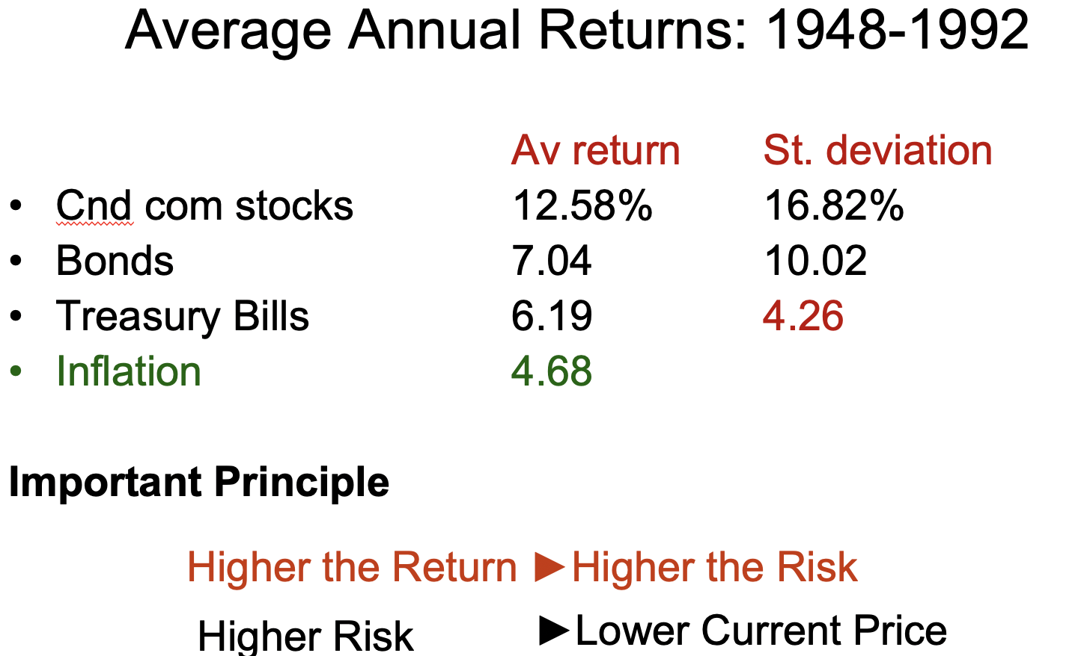

inflation risk

2.51%

4.Portfolio of Stocks

**Go from individual asset to portfolios**

We start from two risky assets. Most of the intuition carries to the case of more than two risky assets.

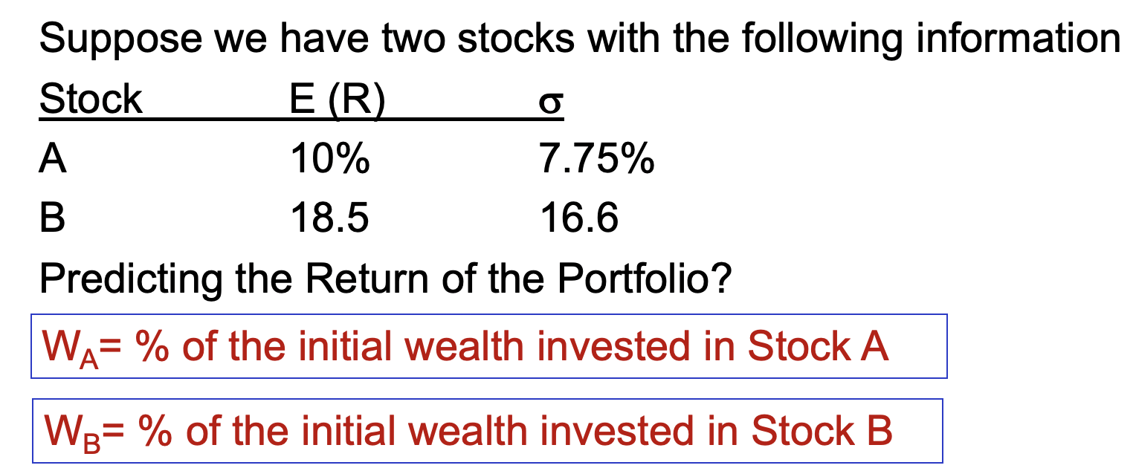

asset allocation

The expected return of a portfolio is simply the weighted average expected returns of all the individual assets in the portfolio

E(RP) = WA E(RA) + WB E (R B )

WA + WB = 1 (wealth constraints)

or

E(RP) = WA E(RA) + (1-WA) E (R B )

Variance:

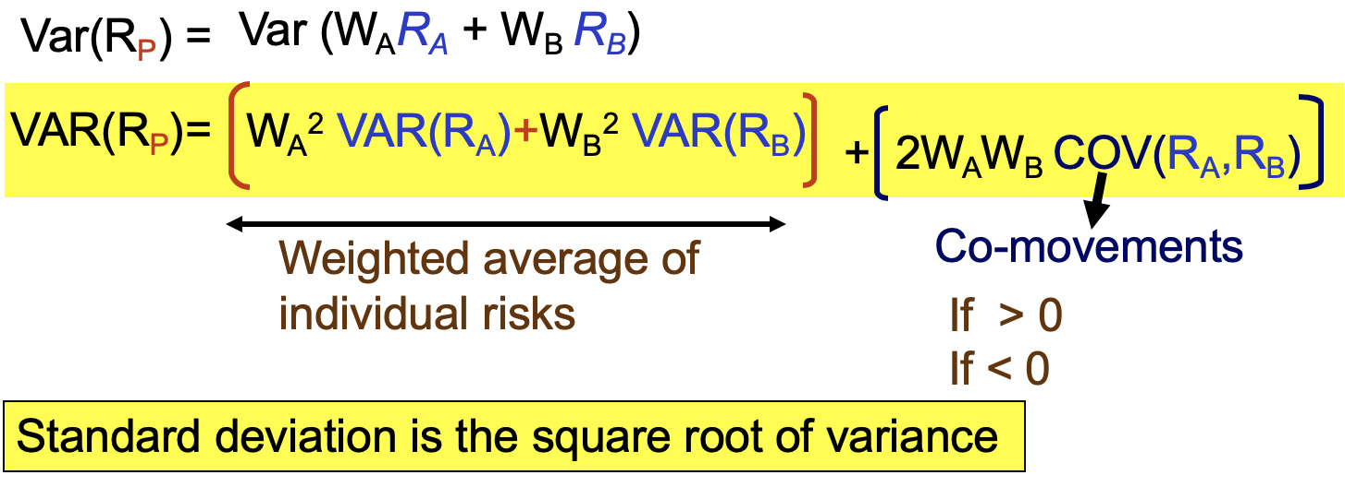

risk averse

You cannot change weighted average of individual risks because it is decided by the business,

so covariance is the key

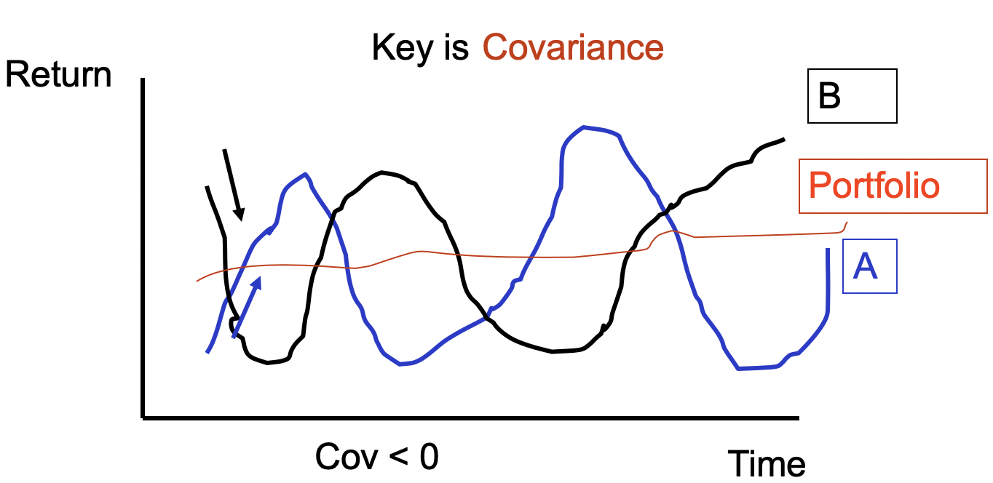

Good for investors who prefer stable income

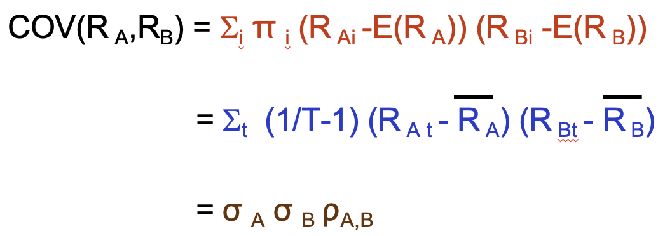

correlation

ex post

ex ante

<Example>

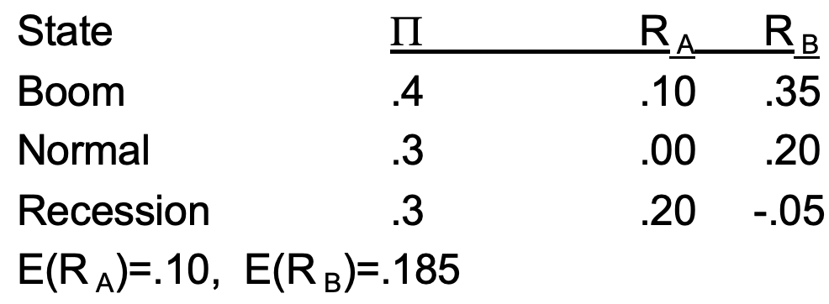

COV (RA,RB)=0.3(-0.1)(0.2-0.185)+0.3(0.1)(-0.05-0.185)=-0.0045-0.00705=-0.0075

5. Diversification

Only Objective: minimize risk

Process of holding multiple assets in the same class or across class of assets

Why? prefer more predictable path of income

[Covariance Variance Matrix]

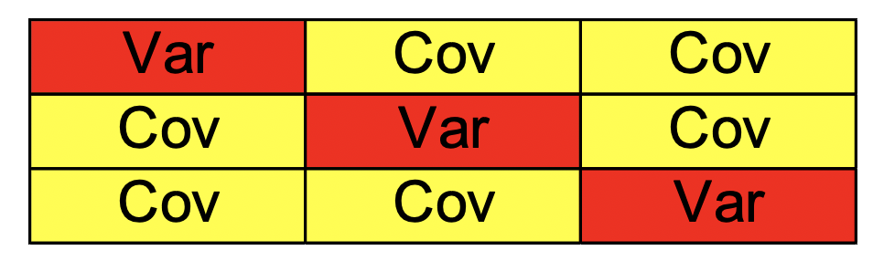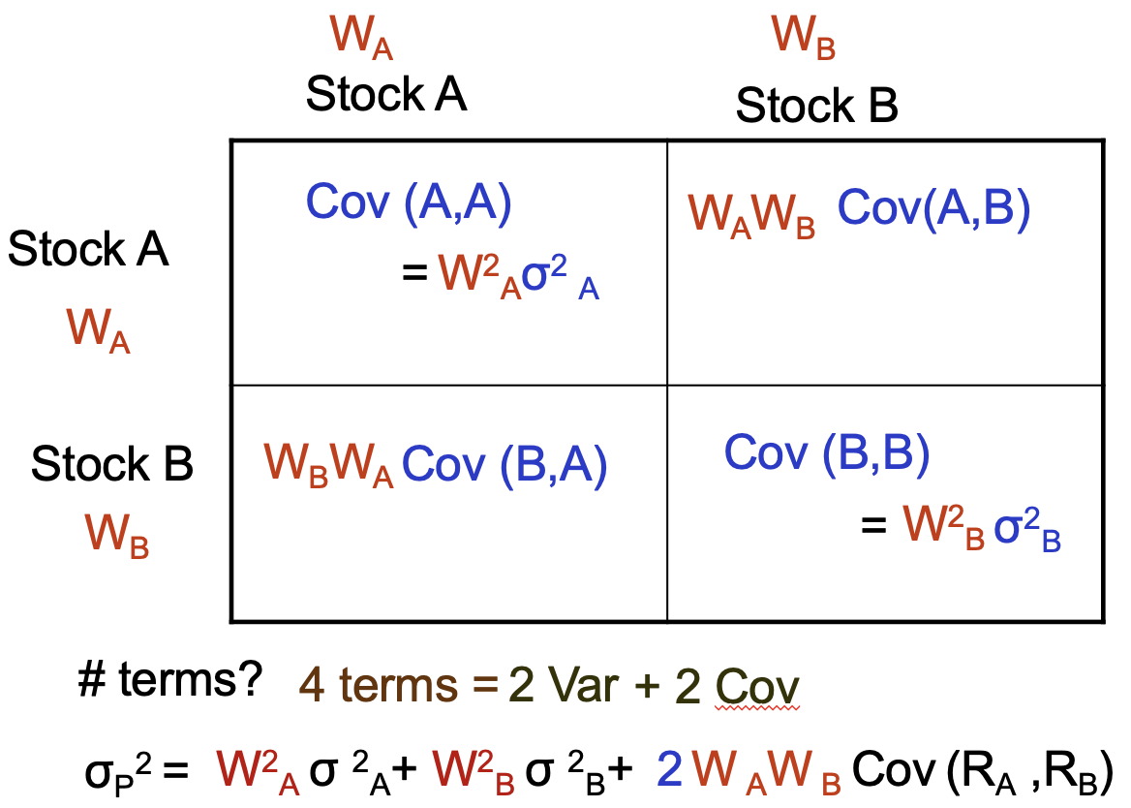

Symmetry

<Example 5>

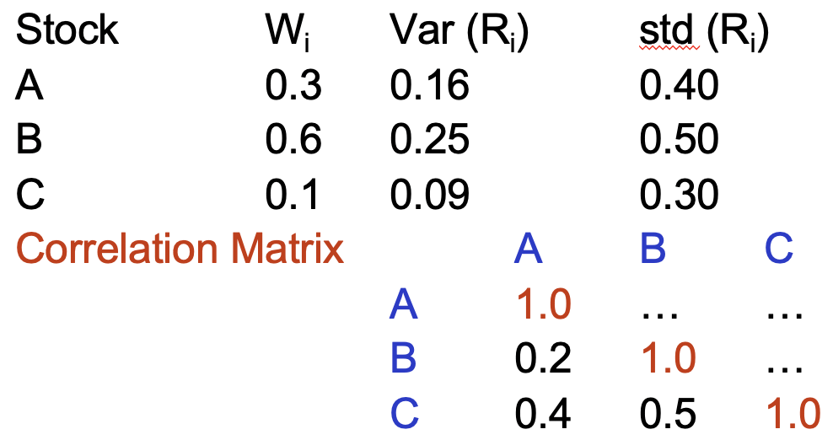

Var(Rp)=0.3^2*0.16+0.6^2*0.25+0.1^2*0.9

+2*0.3*0.6*(0.4*0.5*0.2) A,B

+2*0.3*0.1*(0.4*0.3*0.4) A,C

+2*0.6*0.1*(0.5*0.3*0.5) B,C

**[Impact of diversification upon risk]**

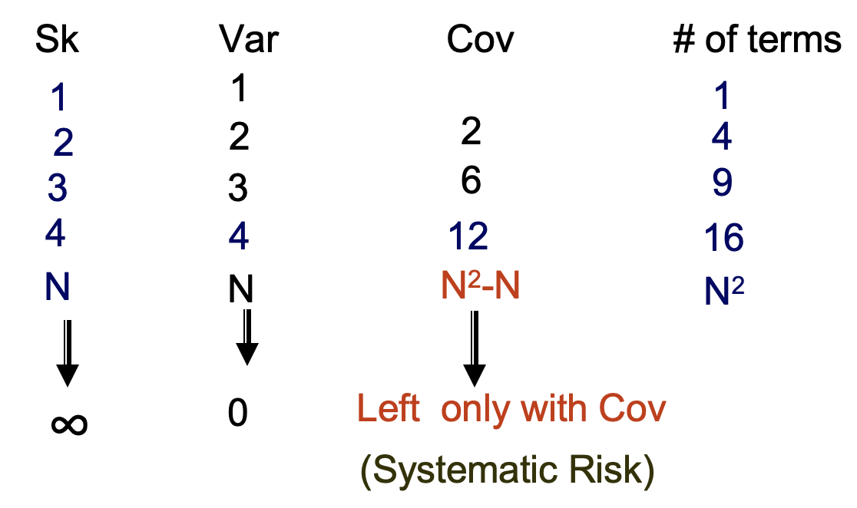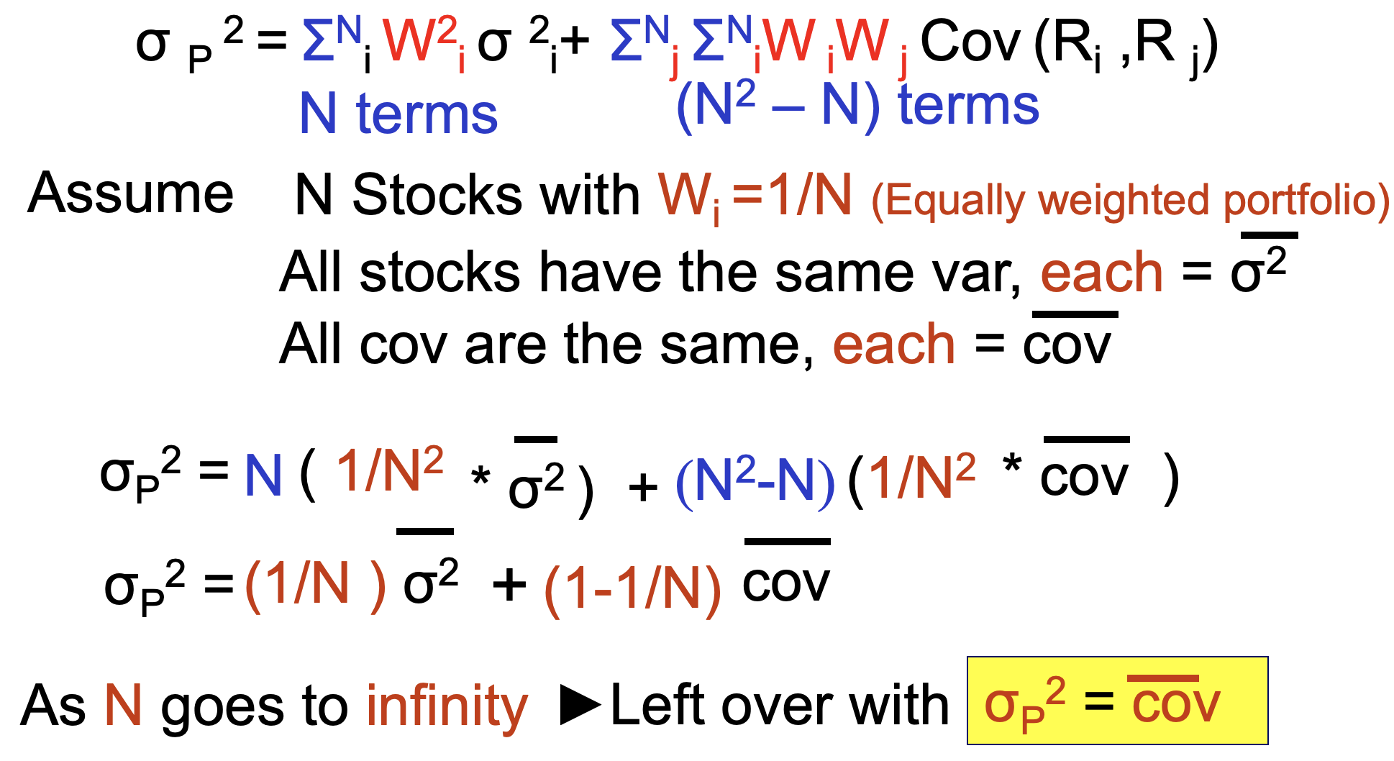

Eliminate firm-specific (unsystematic) risk

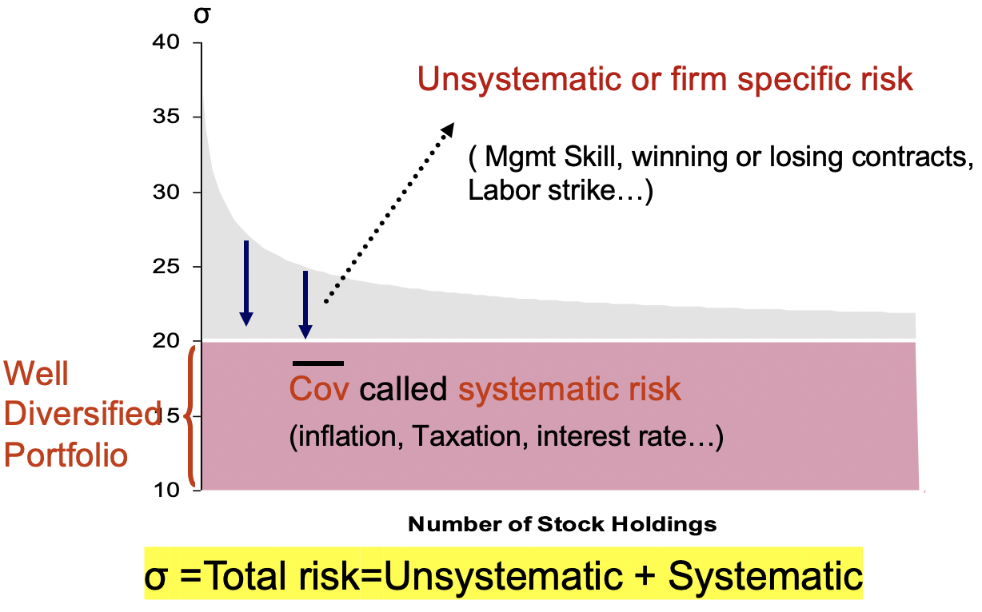

►Mutual Fund

<Example 6>  
Based on data for 1982-2010, we find that σGE = 6.49% and σIBM=8.10%

The correlation between GE and IBM is 0.377

variance of an equally weighted portfolio

Var=0.52*0.06492+0.52*0.0812+2*0.5*0.5*(0.0649*0.081*0.377)=0.00368

σ = 0.0607 or 6.07%

This portfolio is less risky than either of GE and IBM

►Benefit of diversification

[Condition for diversification]

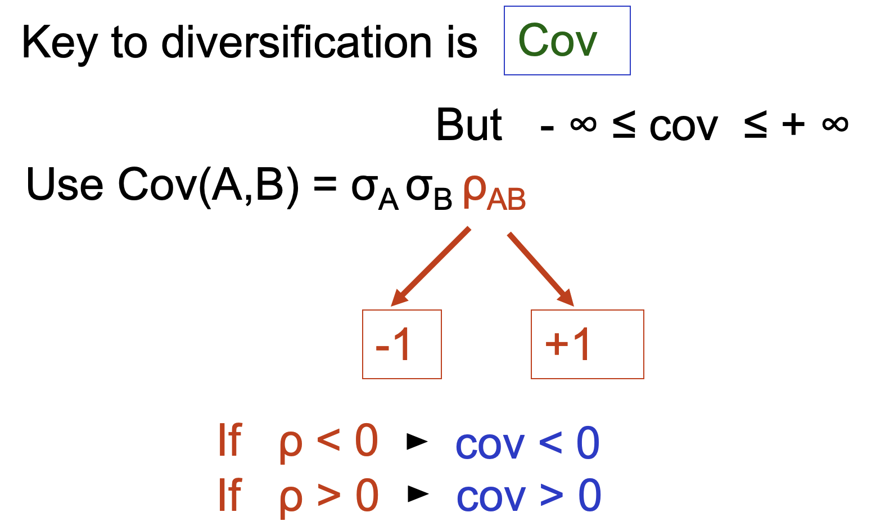

**Key to diversification is Correlation**

* **Case 1 ρ A,B= 1**

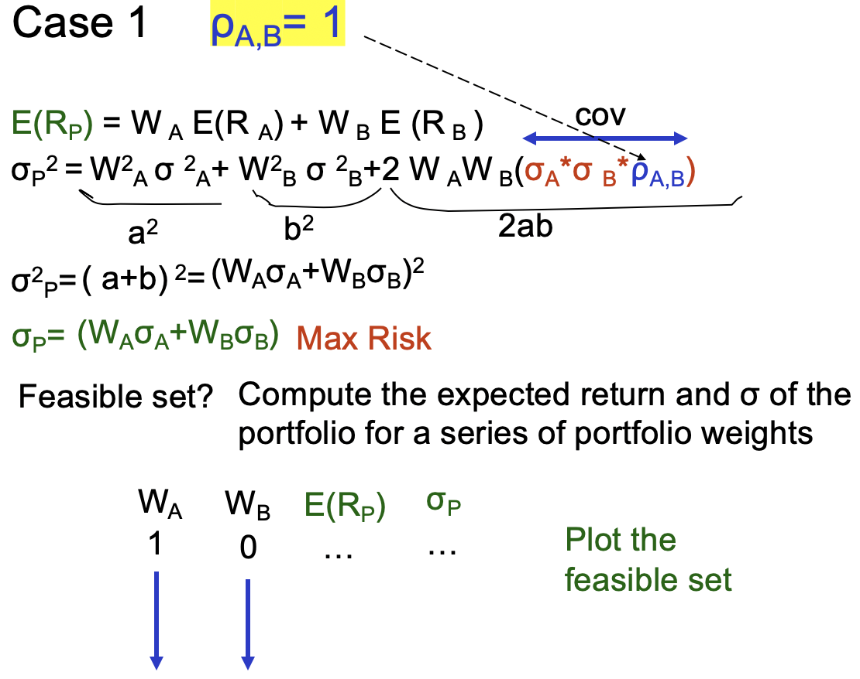

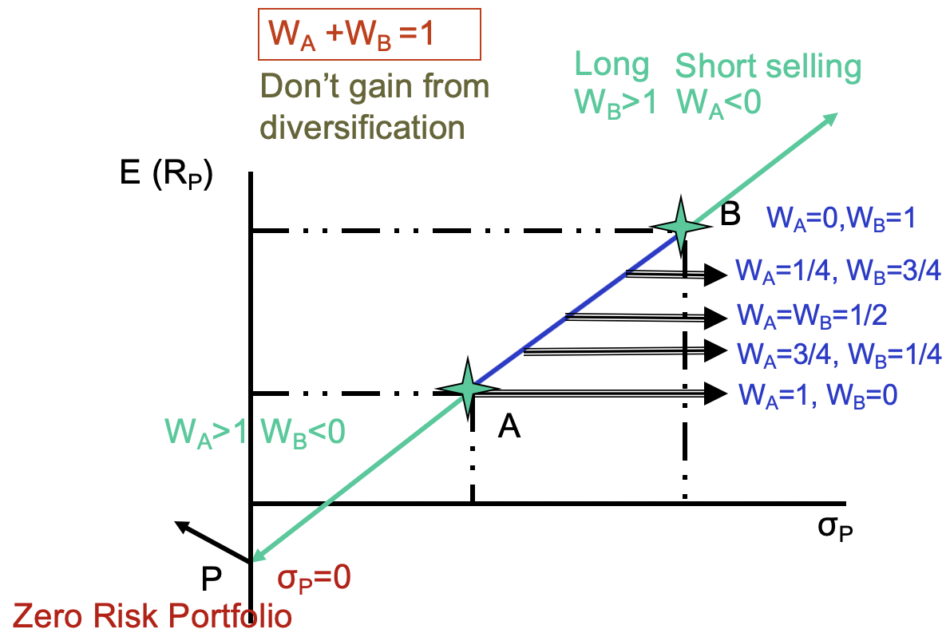

A: optimal

It’s not worth to sacrifice return (the return of the portofolio is even less than the return of a single stock) for lower risk

 corner portfolio:

A portfolio where security enters or leaves the efficient set

* **Case 2 ρ A,B= -1**

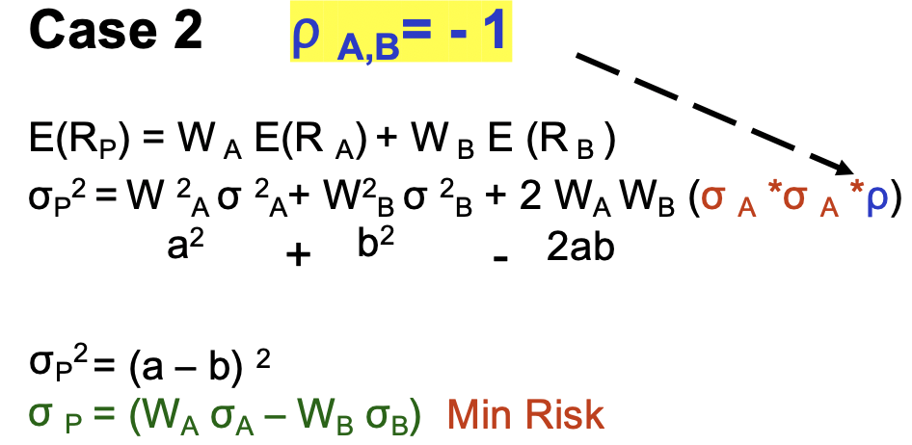

………Plot the feasible set

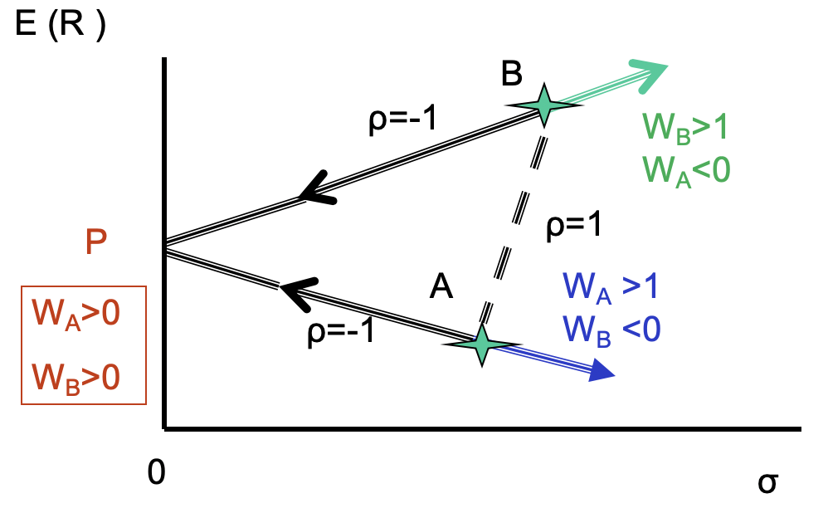

Short selling is not effective here

P: optimal

What is the asset allocation between A and B to achieve zero risk portfolio?

Method 1 set σP = 0and solve for WA and WB

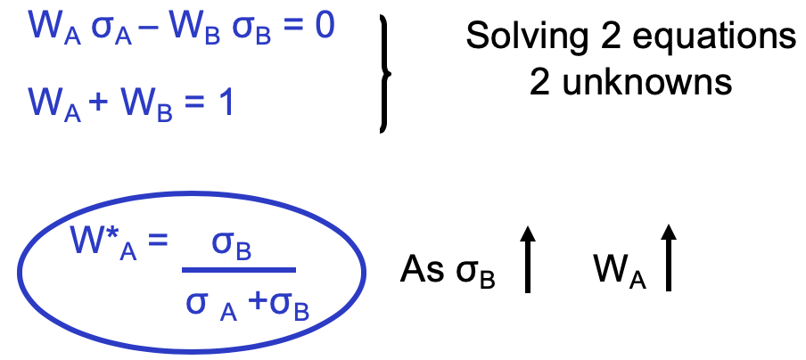

risk of B increases, increase weight of A----risk averse

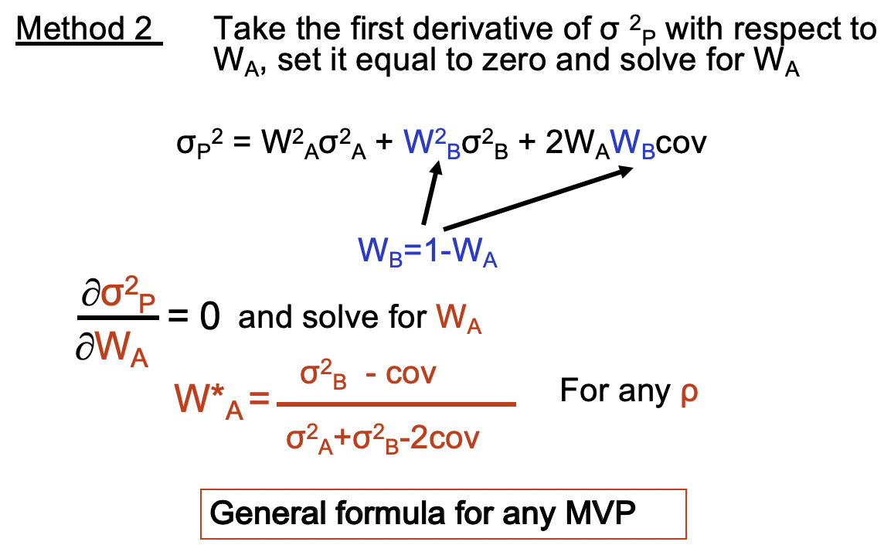

Set corr=-1, same answer

Minimal Variance Portfolio (Lowest Risk Portfolio)

<Example 7>

σA=10% σB=20% ρ = -1

WA = 0.67

WB = 0.33

* **CASE 3 ρ A,B= 0**

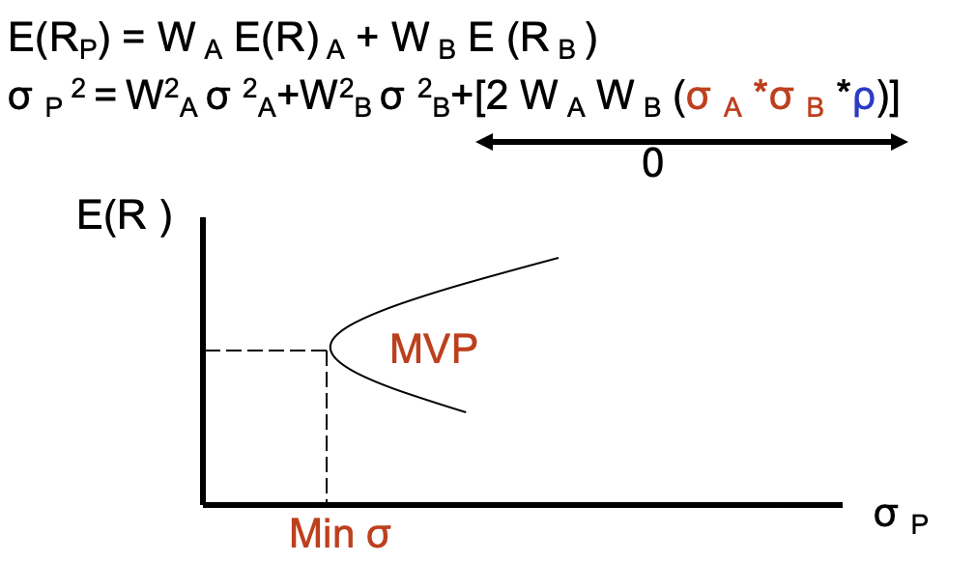

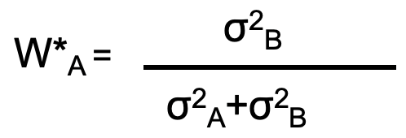

<Example 8>

σA=10% σB=20% ρ = 0

WA = 0.8

WA = 0.2

🡪 σp =0.0894 Not possible to achieve 0

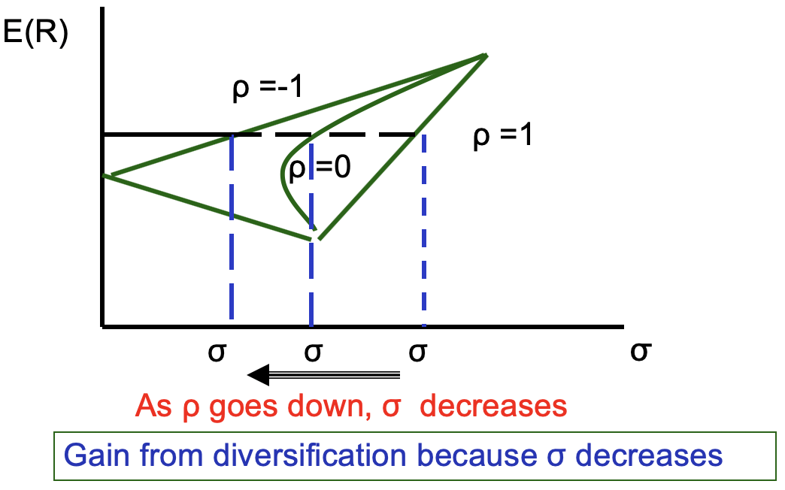

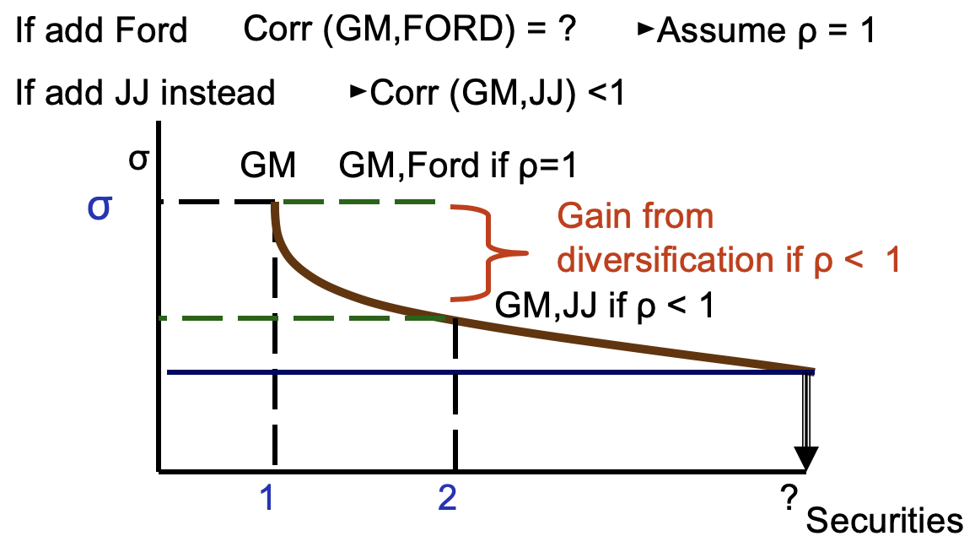

Need 20-30 stocks to achieve fully-diversified portfolio practically

6. Efficient Portfolio – Markowitz Method

An ***efficient portfolio*** is the one that:

*Max Return given Risk or*

*Min Risk given Return*

The set of efficient portfolios is called the ***efficient frontier***

[Mean Variance Model-Markowitz]

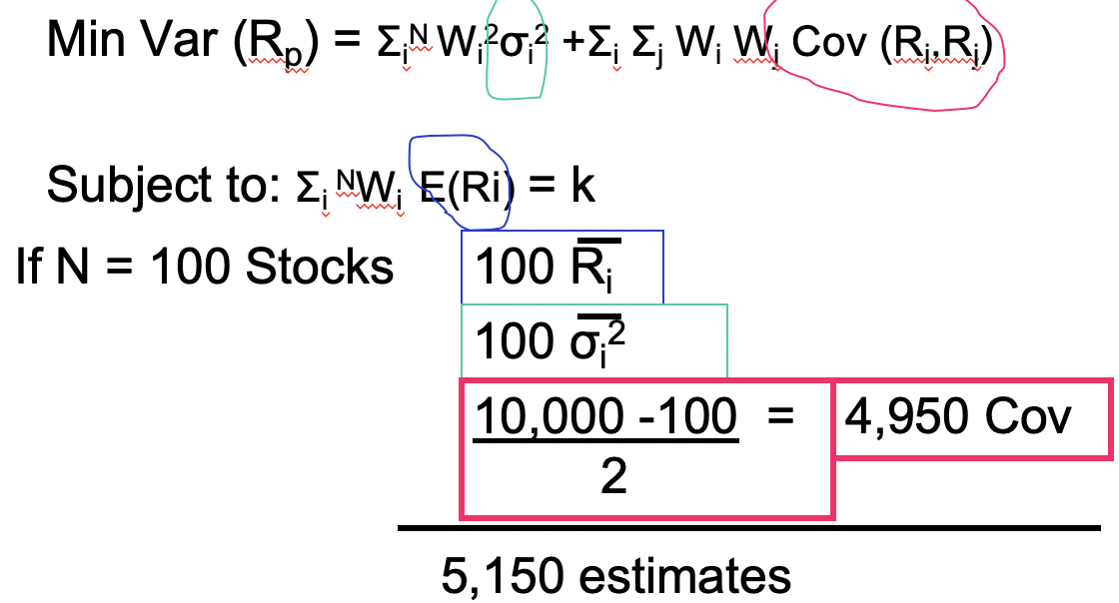

symmetry

* **Case 1 2 Risky Assets**

σ P 2 =W 2A σ 2A+ W2B σ 2B+ 2 WAWB Cov (RA,RB)

W A E(RA) + (1-W A) E (R B ) = k

**decision variables** W A, W B

**inputs** σ 2A, σ 2B,  Cov, E(RA), E(RB)

You can solve this using the ***Solver*** in Excel

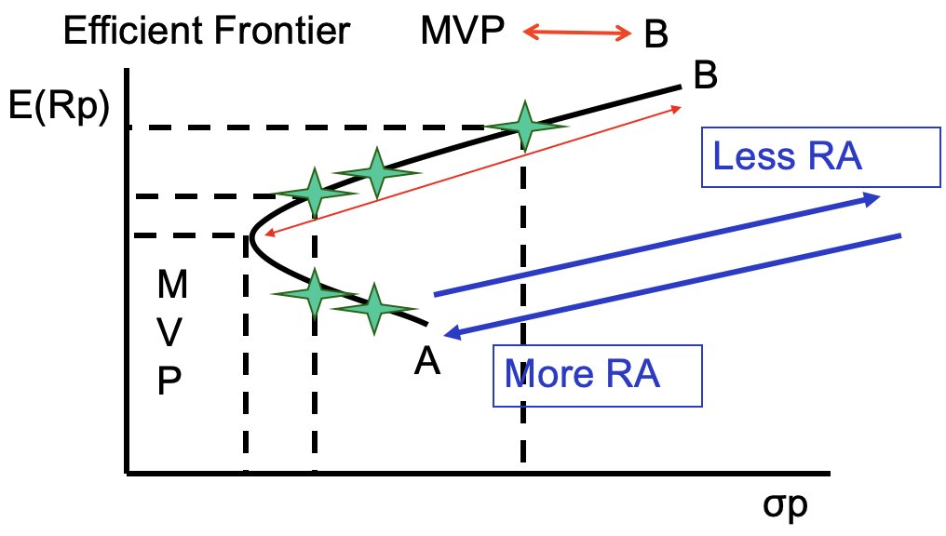

Separation in Portfolio (Managers Investors)

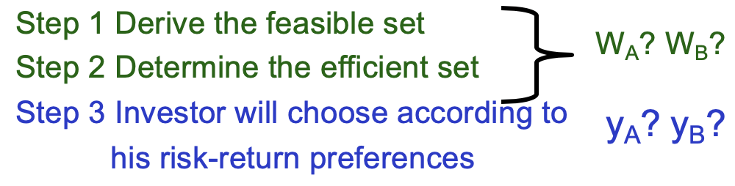

different notation

<Example 9>

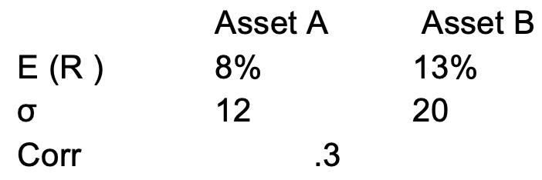

What is the asset allocation if an investor requires 10%?

10% = y 8% + (1-y) 13%

🡪 y = 0.6 or 60% in A

1-y = 0.4 or 40% in B

Risk level of the portfolio?

Var= 0.62*0.122 +0.42*0.22+2*0.6*0.4*(0.12*0.2*0.3)=0.01512

σ p = 0.123

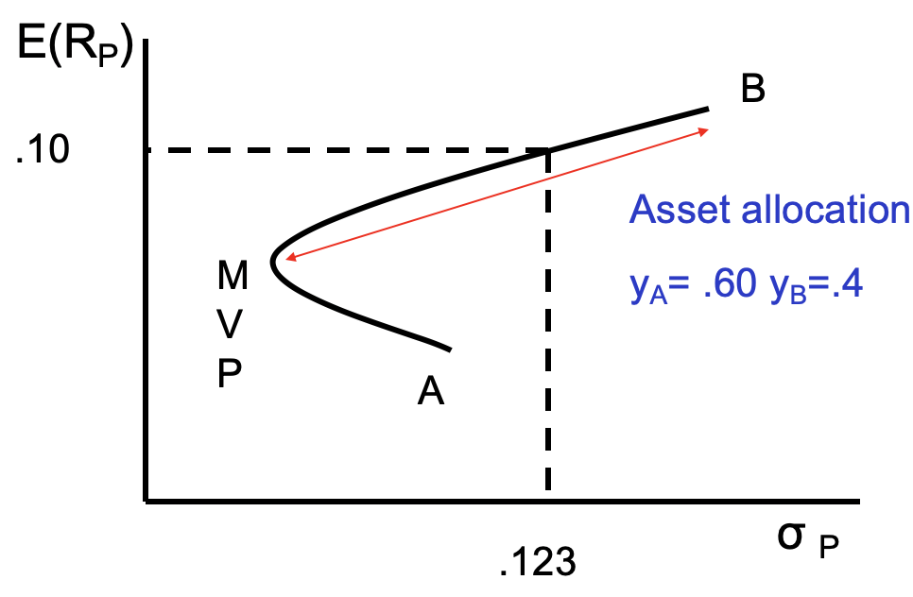

* **Case 2 Two Risky Assets & One Risk Free Asset**

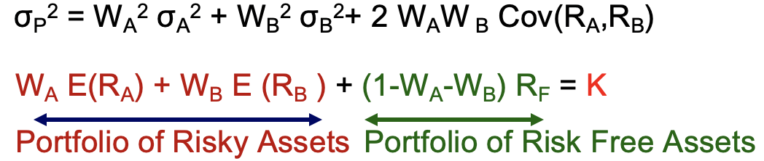

constraint

Asset allocation decision is concerned with how you allocate your funds in broad asset classes :

the risk free asset and the portfolio of risky assets.

Step1 Investment Process

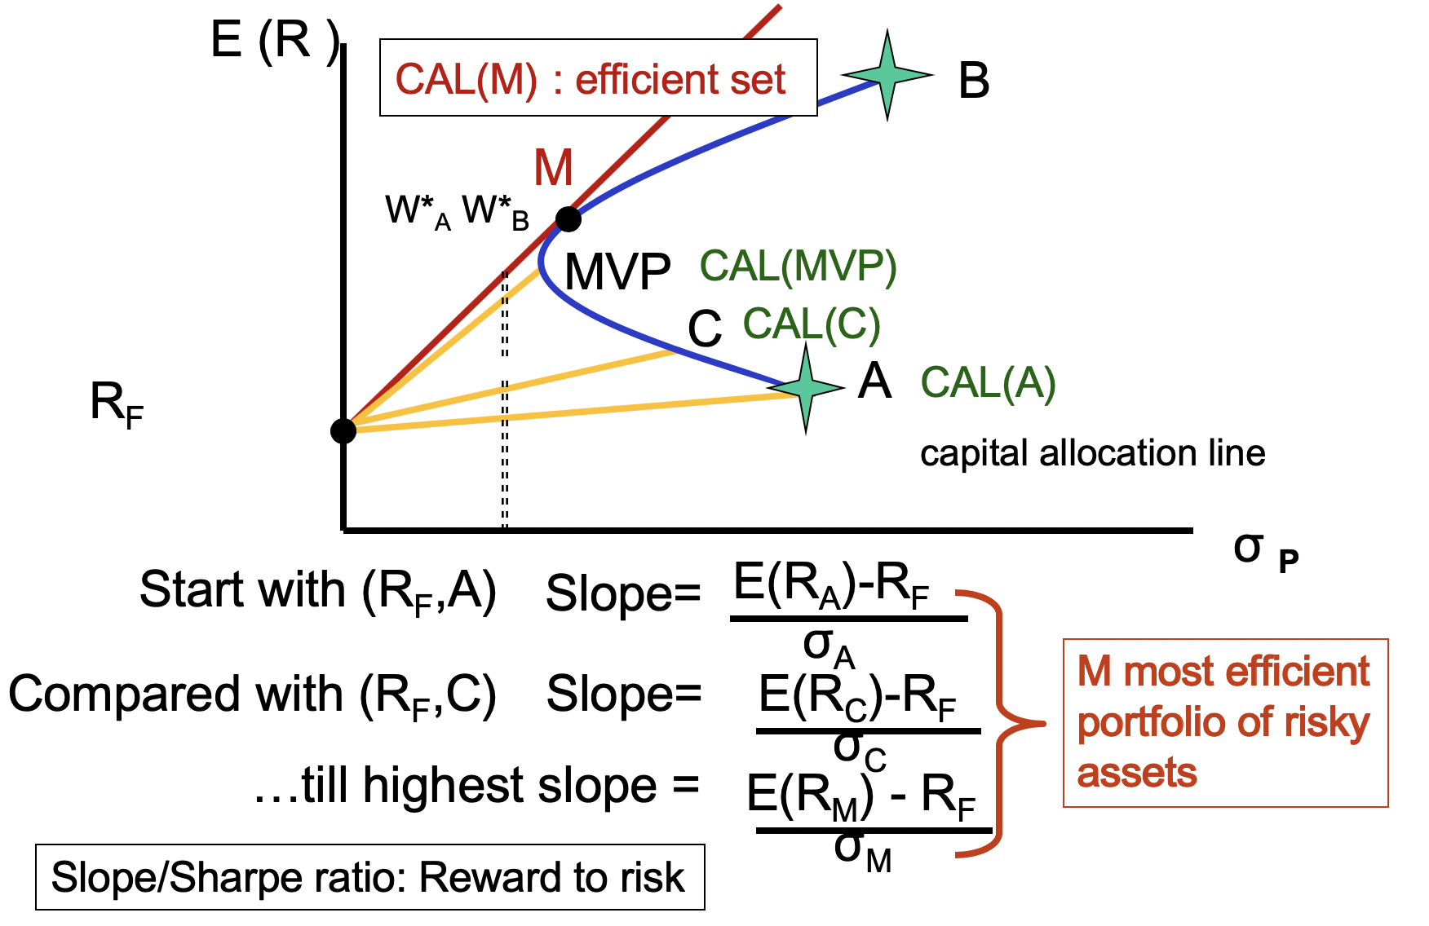

better than only two risky assets!

The slope of the CAL measures the excess return being earned per unit of risk.

**M** is the **optimal portfolio of risky assets** which dominates all other risky portfolios (irrespective of risk preferences)

►This optimal risky portfolio is the same for everybody regardless of how risk averse you are

►Everybody holds a combination of risk-free asset and the optimal risky portfolio

*Note: You can solve the optimal portfolio “M” using Solver in Excel*

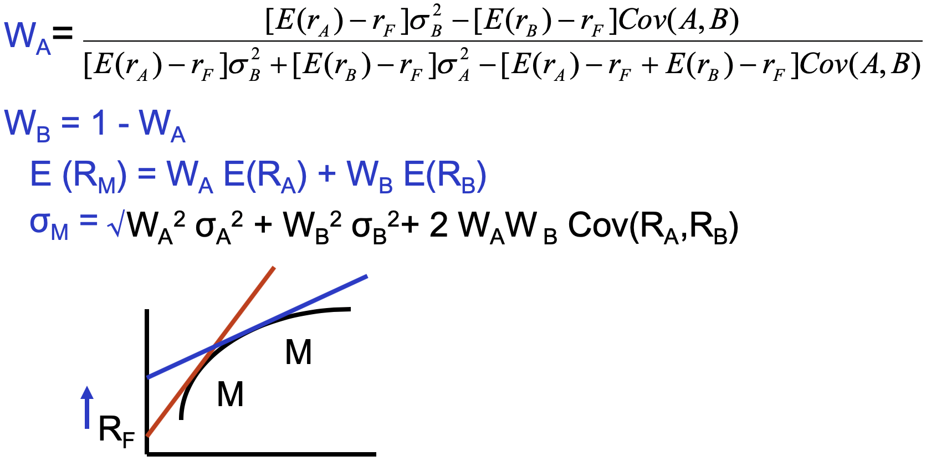The following formula gives the weights for the optimal portfolio comprised of only two assets:

<Example>

The expected rates of return on stocks A and B are 11% and 14% respectively. The risk free rate of return is 6%.

The standard deviation of stock A is 10% annually, while that of stock B is 11%.

If you could invest only in T-bills plus only one of these stocks, which stock would you choose?

The reward to variability ratio of the stock is:

SA = (11-6)/10=0.50

SB = (14-6)/11=0.73

Step 2 Investor’s Choices

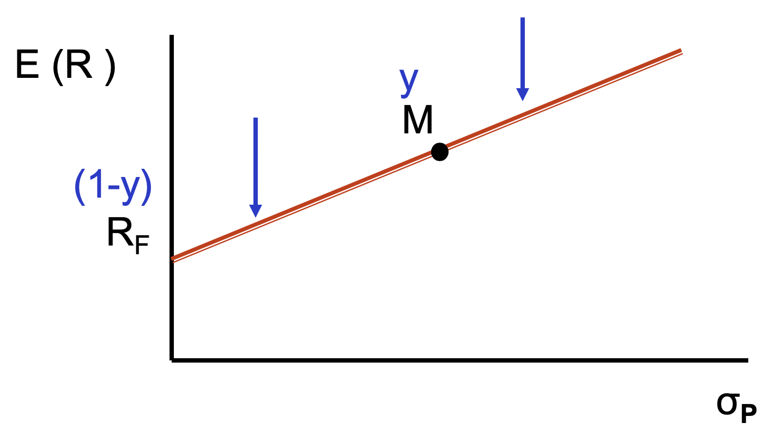

more risk averse

less risk averse

Asset Allocation: How Much Risk Can You Stand? (Risk aversion)

Once you have decided to hold a portfolio “M”, you need to decide what mix of risky assets and risk free asset

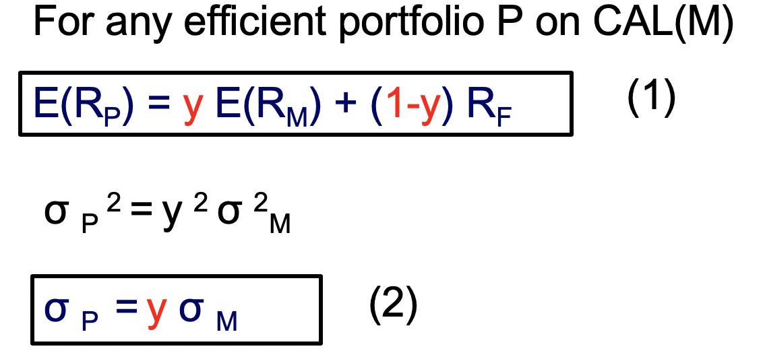

**7. Capital Market Line (CML)**

Substitute (1) into (2) and rearrange

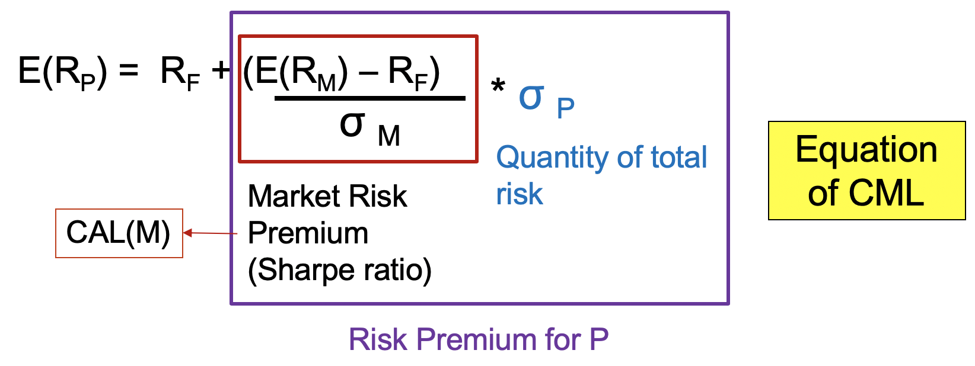

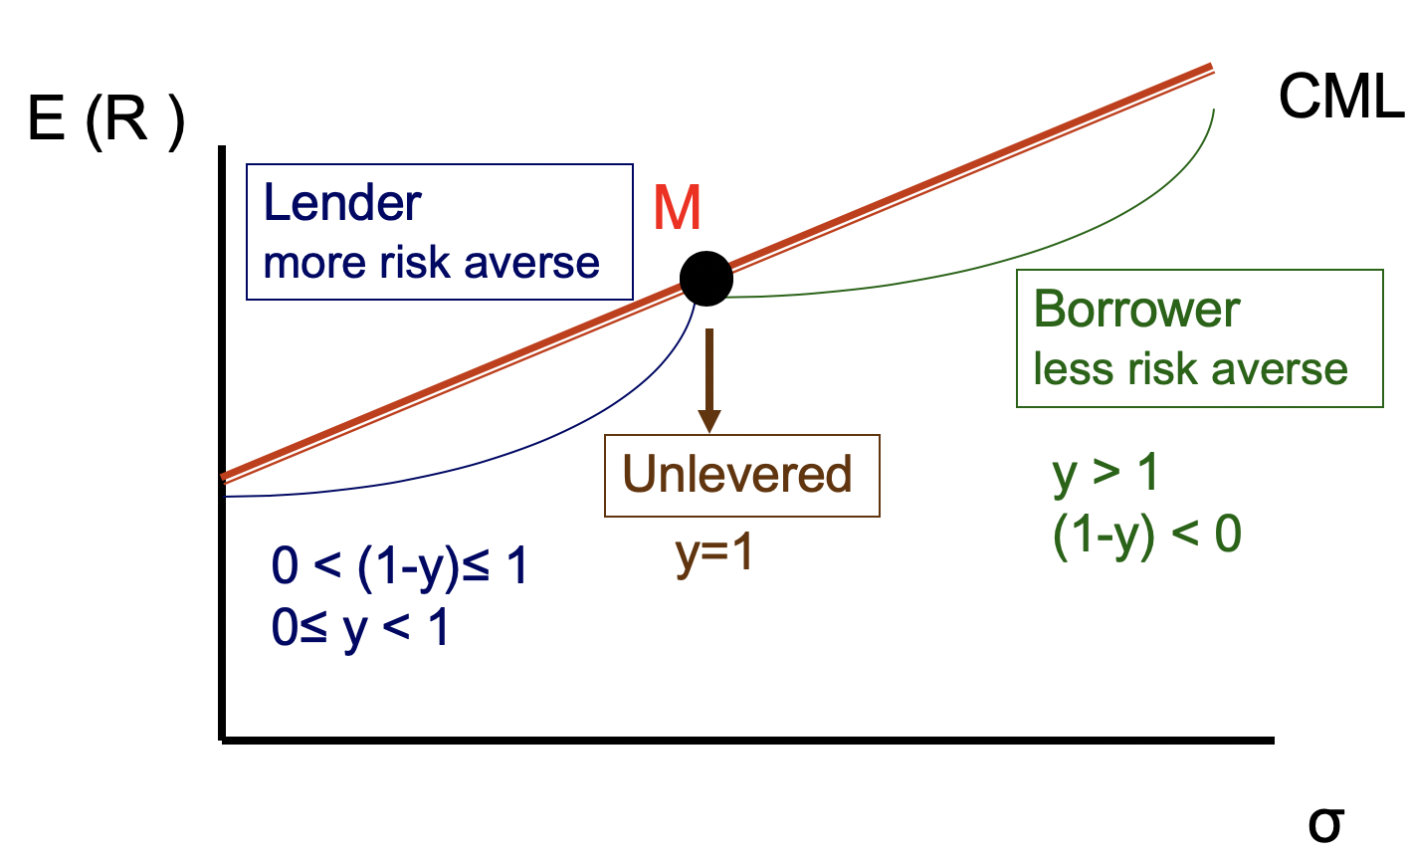

Risk Aversion and Asset Allocation

►Greater levels of risk aversion lead to larger proportions of the risk free asset (Rf)

► Lower levels of risk aversion lead to larger proportions of the portfolio of risky assets (M)

► Higher levels of risk for high levels of returns result in leveraged combinations

<Example 10>

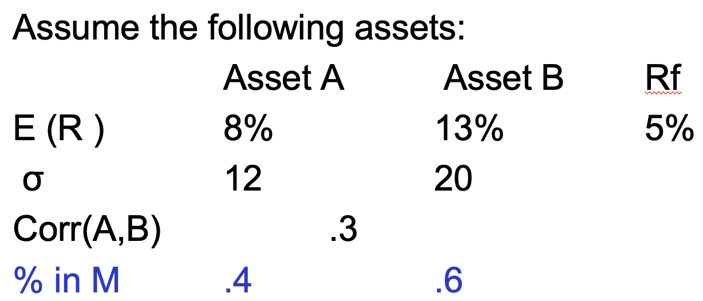

1. What is expected return given σ **P** = 10%?

E(RM) = 0.4*0.08+0.6*0.13=0.11

σM2 **=** 0.42 *0.122+ 0.62*0.22+2*0.4*0.6*0.12*0.2*0.3

σM = 0.142

E(RP)=0.092 or 9.2%

It’s the **maximum expected return** based on your risk preference

2) **Optimal asset allocation**

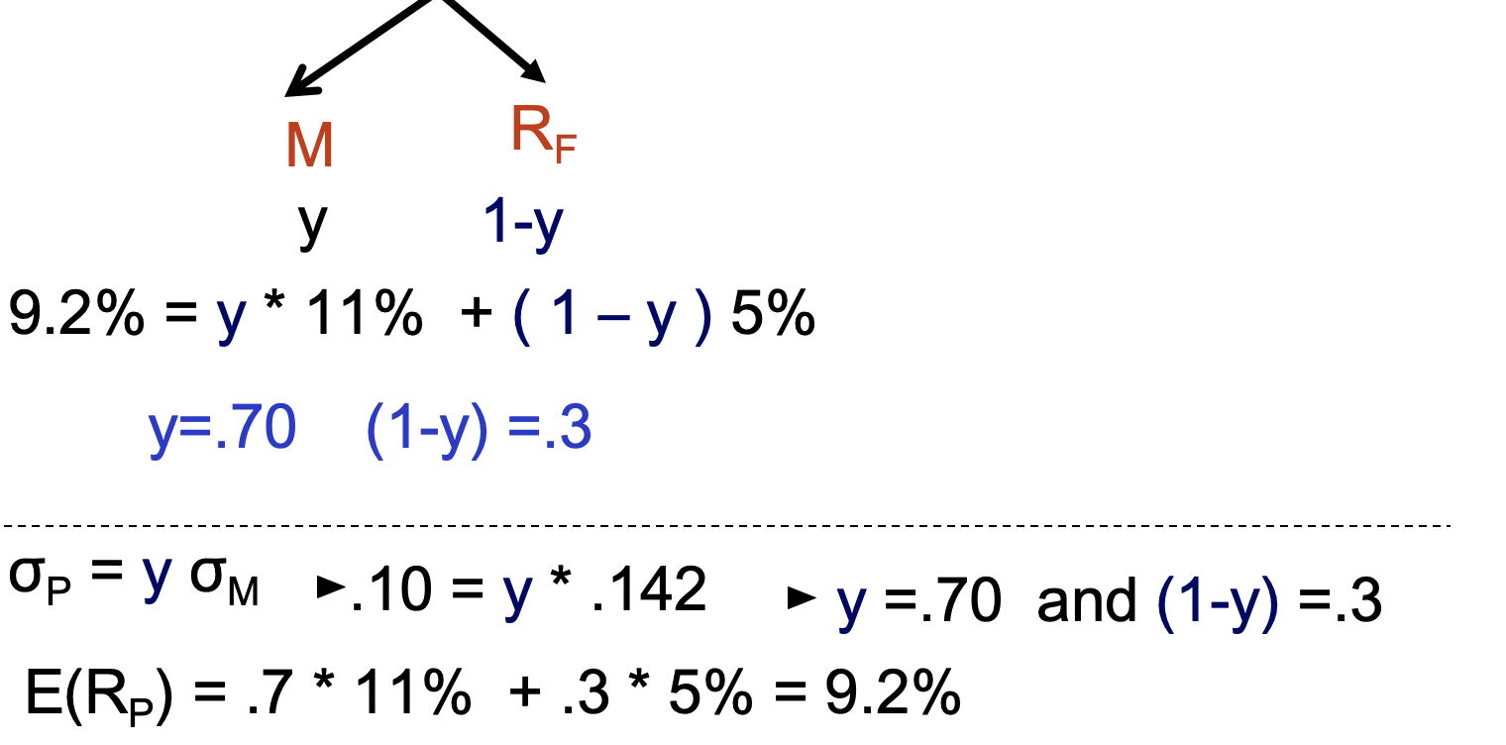

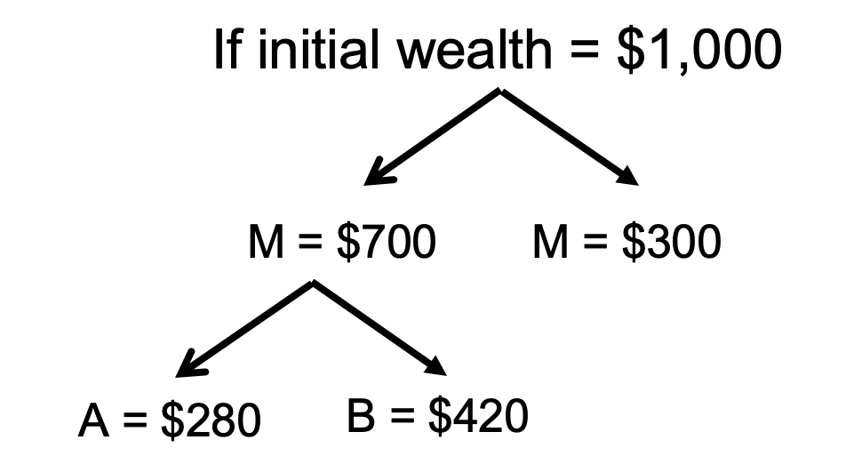

Over 75% variation in performance measured by policy weights (asset allocation)

3) Asset allocation given A= 2?

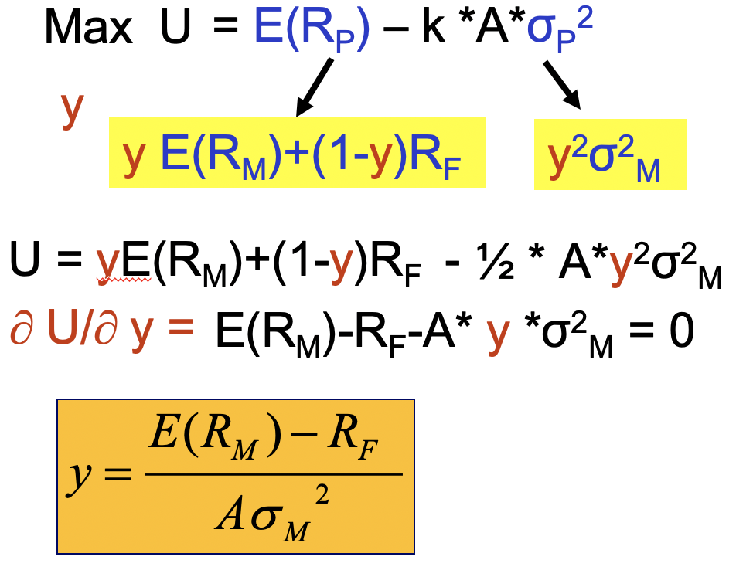 y=1.49

Given W=$1000 🡪 borrow 48% of $1000 to raise $480 and invest $1480 in M (short sell)